**APPLICATION CONTAINERIZATION**

**LAB EXPERIMENT 11**

**SUBMITTED BY:**

NITISH KUMAR SINGLA

500071913

R171218126

**SUBMITTED TO:**

HITESH KUMAR SHARMA SIR

**Prepare and Implement Docker Container Restart Policy**

We've created a special container which outputs a message and then exits with code 1 to simulate a crash.

You can launch an instance using

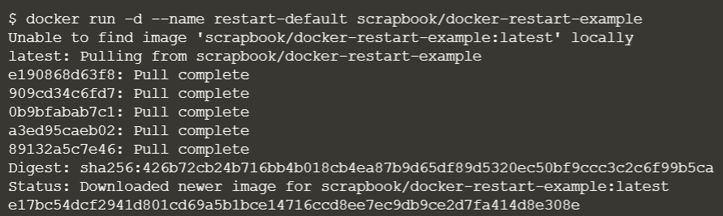

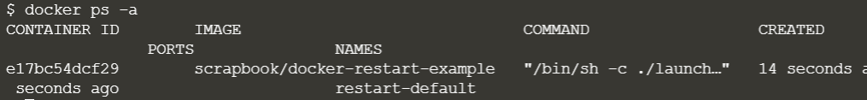

While the logs will output our message, which in real-life would hopefully indicate information to help us diagnose the issue.



The option --restart=on-failure:# allows you to say how many times Docker should try again. In the example below, Docker will restart the container three times before stopping.



As we can see from the logs, it was launched on three occasions.

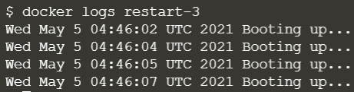

Use the always flag to automatically restart the container when is crashes for example



You can view the restart attempting via the log

